GTAA Factor Portfolio — Project 2 Submission Report
Columbia University · MAFN · MATH 5380 · Spring 2026
This report summarizes the inputs, methodology, and results for our long/short factor-based GTAA portfolio. The submitted strategy is the expanded six-sleeve implementation organized into two economic factor families: Cross-Asset Momentum and Cross-Asset Carry. The original three-sleeve portfolio is retained as a benchmark, but the notebook-first submission package centers on the expanded design.
Submission format. Following the teaching-team clarification, our final package is notebook-first rather than Excel-first. All required charts are embedded in notebooks/FINAL_SUBMISSION.ipynb, and the dedicated audit notebook notebooks/09_no_lookahead_verification.ipynb documents the no-look-ahead checks.
Reporting convention. In line with the project specification, annualized return is the arithmetic annualized simple return 12 × average monthly simple return, annualized volatility is the population monthly standard deviation times sqrt(12), and the information ratio is the ratio of those two quantities.

1. Inputs and Investment Universe
The final implementation uses monthly data and monthly portfolio updates. The expanded live sample runs from December 2005 to November 2025 after applying the required signal and covariance lookbacks.
Sleeve | Assets | Signal | Source
Equity Momentum | 10 country ETFs | 12-1 momentum from returns | provided country-equity series / Yahoo-aligned ETF returns
Commodity Momentum | 12 commodity ETFs | 12-1 momentum from prices | Yahoo Finance
Fixed-Income Momentum | 10 bond ETFs | 12-1 momentum from returns | Yahoo Finance
FX Momentum | 6 currency ETFs | 12-1 momentum from prices | Yahoo Finance
Fixed-Income Carry | 10 bond ETFs | yield-proxy carry | FRED + ETF return panel
FX Carry | 6 currency ETFs | foreign 3M rate minus USD 3M rate | FRED + FX ETF return panel
The final universe therefore spans equities, commodities, fixed income, and currencies, making the portfolio a genuine cross-asset GTAA process rather than a narrow equity-bond extension.
Data loading, cleaning, and alignment are documented directly in notebooks/FINAL_SUBMISSION.ipynb, including date parsing, numeric coercion, missing-value treatment, and the partial-universe alignment logic used by the covariance and volatility-scaling steps.

2. Factors and Portfolio Construction

2.1 Factor-family interpretation
The assignment requires at least two factors and limits the use of momentum/value-style examples. Our implementation is organized into two economic factor families:
- Cross-Asset Momentum
- Cross-Asset Carry
The multiple momentum sleeves in the final implementation are sleeve-level expressions of the same momentum family, not separate unrelated factor types. This preserves a single momentum factor in the assignment sense. The teaching team confirmed our original momentum-plus-carry interpretation on May 5, 2026, and the expanded version keeps that same two-family logic while broadening the investable sleeves.
Factor family | Sleeve implementation | Construction
Cross-Asset Momentum | Equity, Commodity, Fixed-Income, FX Momentum | rank-standardized long/short weights from 12-1 signals
Cross-Asset Carry | Fixed-Income Carry, FX Carry | rank-standardized long/short weights from carry signals

2.2 Monthly construction process
- Compute sleeve signals using only information available at month-end t.
- Convert each sleeve signal into cross-sectional rank-standardized raw weights.
- Estimate a 36-month population covariance matrix at each month-end.
- Scale each sleeve to target 1% annualized ex-ante volatility.
- Equal-weight sleeves within each factor family and rescale each family to 1%.
- Equal-weight the two factor families and rescale the final portfolio again to 1%.
- Apply weights formed at month t to returns realized at month t+1.
This satisfies the project’s core construction requirements: at least monthly re-estimation, at least 36 months of prior returns in the covariance matrix, sleeve-level 1% scaling, and final portfolio 1% scaling.

2.3 No-look-ahead controls
Look-ahead bias is explicitly controlled throughout the pipeline.
Control | Implementation
Signal timing | momentum skips the most recent month
Covariance timing | covariance uses only trailing data available through month t
Return alignment | weights at t are applied to returns at t+1
Audit | dedicated verification notebook checks timing, alignment, carry pass-through, and future-shock invariance
Supporting files: notebooks/09_no_lookahead_verification.ipynb, config/project2_gtaa_expanded.yaml, src/gtaa/portfolio/backtester_gtaa_expanded.py.

3. Backtest Results

3.1 Final expanded portfolio
The expanded strategy has 240 realized monthly returns from December 2005 to November 2025.
Strategy | Months | Ann. return | Ann. vol | Information ratio | Avg drawdown | Max drawdown | Annualized turnover
Expanded GTAA (6 sleeves) | 240 | 0.42% | 1.15% | 0.361 | -1.01% | -2.86% | 236.3%

3.2 Benchmark comparison
Metric | Baseline (3 sleeves) | Expanded (6 sleeves)
Annualized return | 0.46% | 0.42%
Annualized volatility | 1.06% | 1.15%
Information ratio | 0.431 | 0.361
Maximum drawdown | -2.83% | -2.86%
The baseline is stronger on pure in-sample efficiency, but the expanded version is the more complete GTAA architecture because it broadens the opportunity set across bonds and currencies while keeping downside risk very similar. This is important because the project is graded on the soundness of assumptions and methodology rather than on maximizing in-sample performance.
Within the expanded strategy, the carry family is the cleaner contributor (IR = 0.326 versus 0.124 for the momentum family). The weaker sleeves are fixed-income momentum and FX carry, which explains the lower final information ratio relative to the baseline benchmark.

3.3 Portfolio growth and drawdown
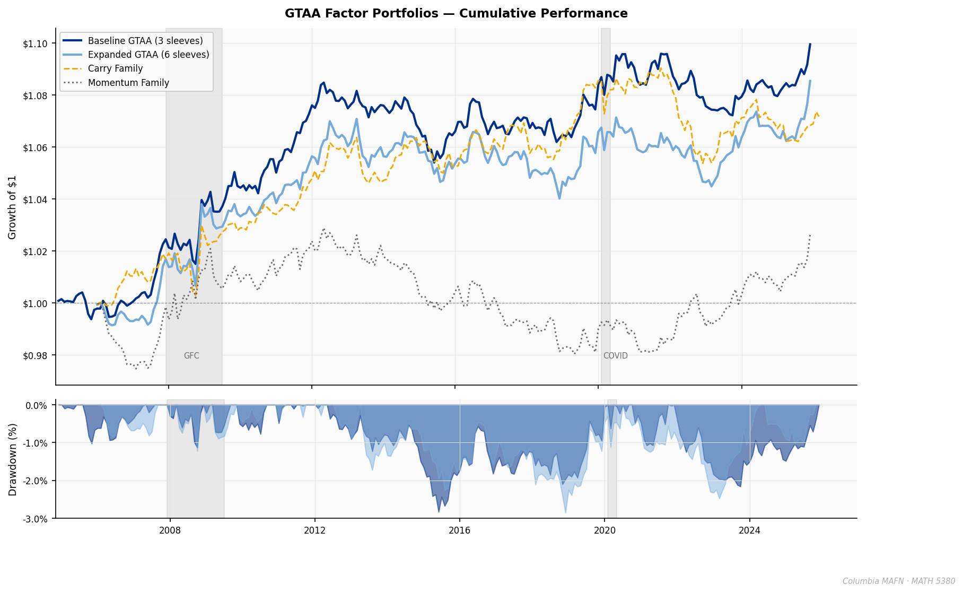
Source figure: [outputs/figures/cu_hero_cumulative.png](outputs/figures/cu_hero_cumulative.png).
This figure shows the growth of $1 for the final portfolio and the benchmark comparison, together with the realized drawdown profile. The expanded strategy remains close to the baseline in cumulative performance and exhibits a similar maximum drawdown.

3.4 Growth of $1 for each sleeve
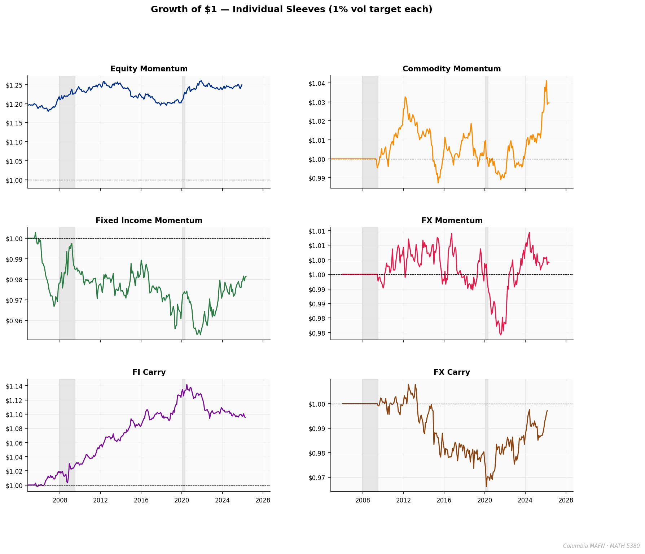
Source figure: [outputs/figures/expanded_sleeve_growth.png](outputs/figures/expanded_sleeve_growth.png).
This six-panel chart addresses the project requirement to show growth of $1 for each factor-mimicking portfolio separately. Equity momentum and fixed-income carry are the strongest sleeve-level contributors; fixed-income momentum and FX carry are the weakest over the final sample.

4. Notebook Deliverables Map
All required charts are embedded in notebooks/FINAL_SUBMISSION.ipynb. The table below maps the assignment requirements directly to notebook sections.
Assignment requirement | Notebook location
Data used / data handling | FINAL_SUBMISSION.ipynb → Sections 1–3
Factors / methodology | FINAL_SUBMISSION.ipynb → Sections 4–7
Raw Factor Weights | FINAL_SUBMISSION.ipynb → Section 5
Factor1 1% Volatility Weights | FINAL_SUBMISSION.ipynb → Section 8
Factor2 1% Volatility Weights | FINAL_SUBMISSION.ipynb → Section 9
Final 1% Volatility Portfolio Weights | FINAL_SUBMISSION.ipynb → Section 10
Gross Returns / Growth of $1 | FINAL_SUBMISSION.ipynb → Section 11
Portfolio Statistics | FINAL_SUBMISSION.ipynb → Section 12
Turnover | FINAL_SUBMISSION.ipynb → Section 13
Covariances / Volatilities / Correlations | FINAL_SUBMISSION.ipynb → Section 14
No-look-ahead audit | 09_no_lookahead_verification.ipynb
The final notebook also renders the numeric final-period covariance and correlation matrices directly beneath the heatmaps, so the matrix requirement is met in both chart and tabular form.

5. Conclusion
Our final submission satisfies the assignment requirements: at least two factors, monthly rebalancing, 36-month covariance estimation, 1% sleeve and portfolio volatility targeting, explicit no-look-ahead timing, embedded charts, and full portfolio-statistics outputs in the consolidated submission notebook.
The central empirical conclusion is straightforward. The baseline is the stronger pure in-sample benchmark, but the expanded version is the more complete GTAA design because it applies the same approved momentum-plus-carry framework across a broader cross-asset universe while maintaining a very similar downside profile.
Limitations and caveats are documented separately in docs/LIMITATIONS.md.

6. Sources
- Assignment brief: docs/Project 2 .pdf
- Final submission notebook: notebooks/FINAL_SUBMISSION.ipynb
- No-look-ahead audit: notebooks/09_no_lookahead_verification.ipynb
- Submission notebook builder: scripts/build_final_submission_notebook.py
- Audit notebook builder: scripts/build_no_lookahead_notebook.py
- Expanded config: config/project2_gtaa_expanded.yaml
- Raw input data workbook: data/raw/multi_asset_universe.xlsx
- Code entry points: src/gtaa/portfolio/backtester_gtaa_expanded.py, scripts/generate_visualizations.py
Prepared from the repository outputs as of 2026-05-08.

